EBay

**Introduction:**

The purpose of the system is to allow users to buy and sell items on a common platform. The platform is similar to the famous eBay e-commerce giant.

**RabbitMQ System Design:**

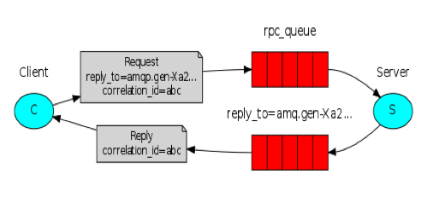

In this architecture, we are maintaining **4** rpc queues and 4 callback queues:

1. **login_queue:** to handle all requests related to login/signup and redirecting to homepage after successful login.
2. **product_queue:** to handle all requests related to rendering information related to a product i.e., selling a product (direct sell and auction sell), buying a product, bidding for a product, searching for a product.
3. **cart_queue:** to handle all requests related to rendering cart information for a user, adding a product to user’s cart, removing products from a user’s cart and handle checkout of the cart.
4. **user_queue:** to handle all requests related to rendering user personal information, user purchase history, user sell history, user bid history etc.

**Queues from the RabbitMQ Management plugin:**

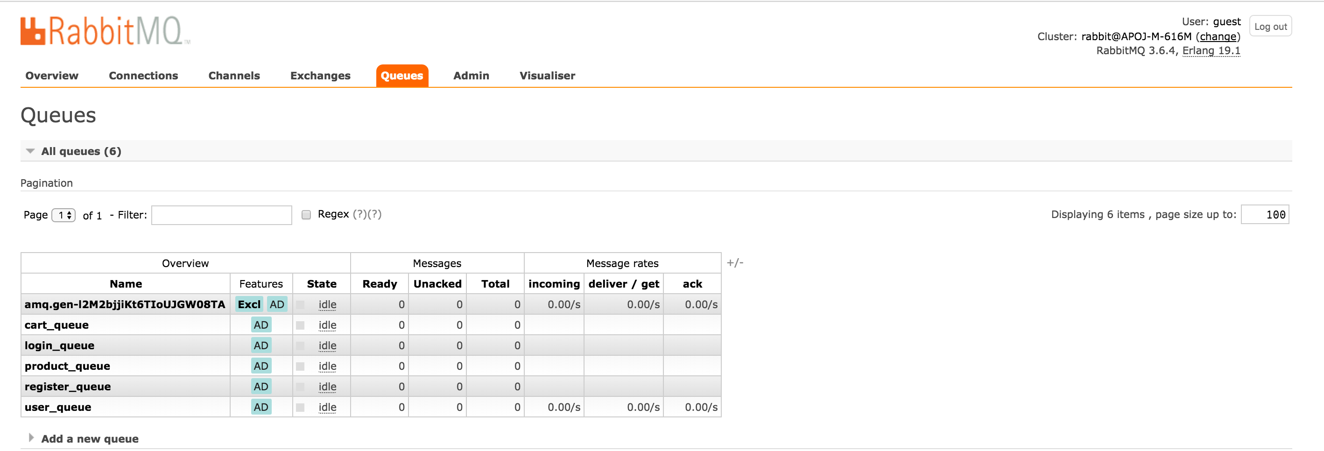

**System Design:**

* The user must login to be able to buy and sell items.
* The user must register first to be able to login.
* **Registration:**
  + The user is provided with a HTML form, where he enters his username, password, email etc.
  + The data is sent to the server for validation.
  + Upon successful validation of each field (using regExp for names, emails, zipcode etc.), the user data is inserted into the Mongo database.
  + Before storing the password, the password is encrypted using bcrypt and express-sessions are stored using Passport JS.

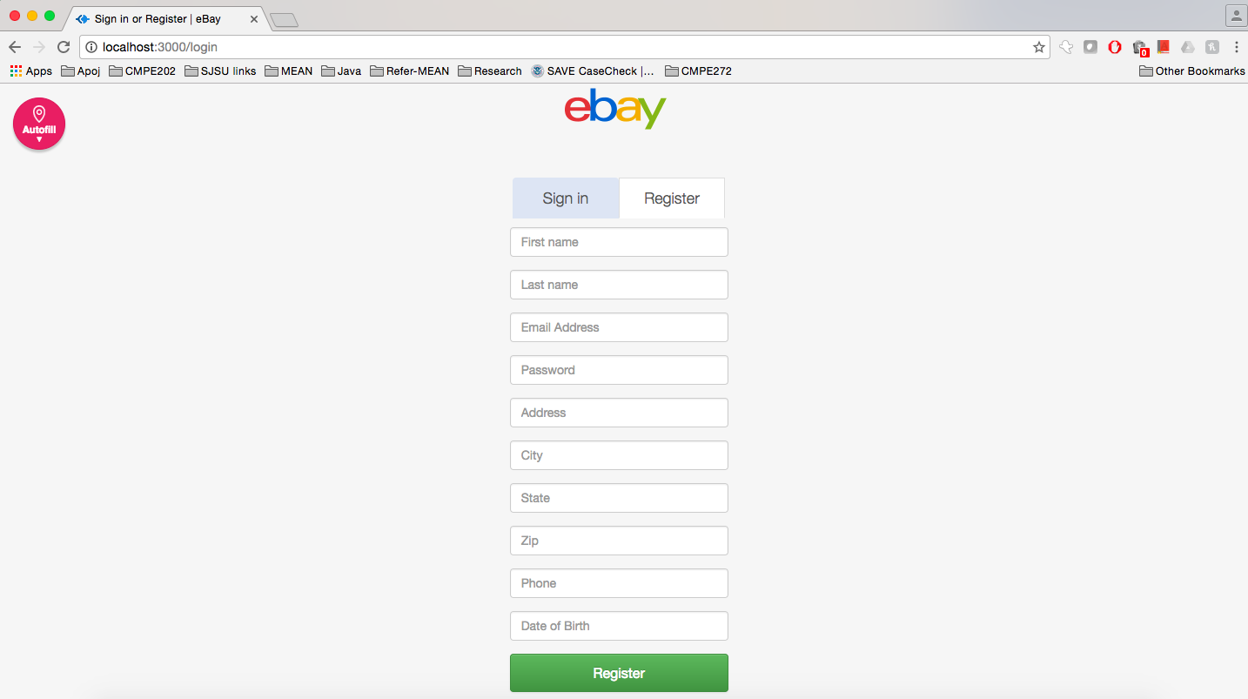

* **Login:**
  + The user must login to the system after registering. The user credentials are verified by the server by querying the “users” collection in the mongo database.
  + Upon successful validation, the homepage is rendered. Here the user can buy, sell items.
  + Express-sessions is used to maintain user sessions with session duration 30 minutes and active duration of 10 minutes. Sessions are authenticated and stored in mongoDB using PassportJS.

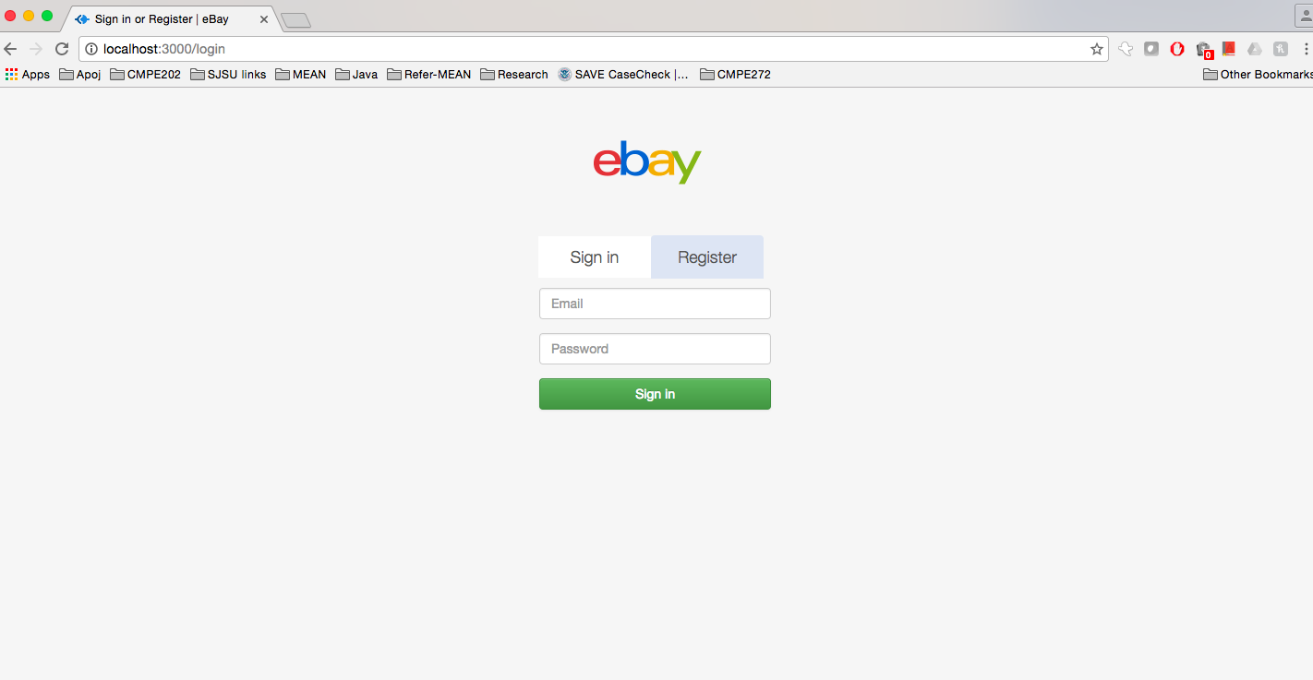

* **Homepage:**
  + The homepage displays all the products being sold by other users.
  + The user can search various categories available.
  + He can also search for products in a specific category.
  + It also consists of navigation to the user cart, user account, purchase history, sell history, bid history and an option to logout.
  + The user can click on specific products to see the product details.
    - From this page he can buy/bid for products.

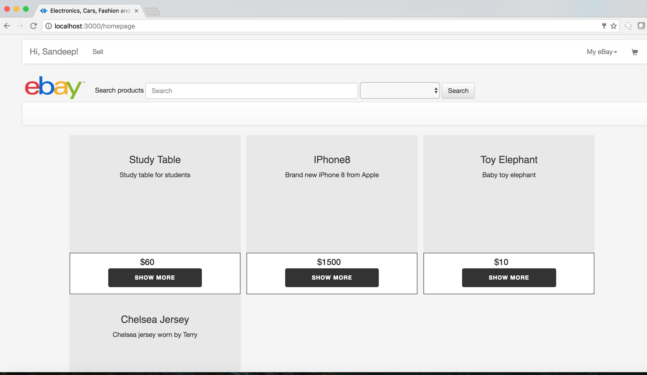

**Search fail for products which don’t exist**

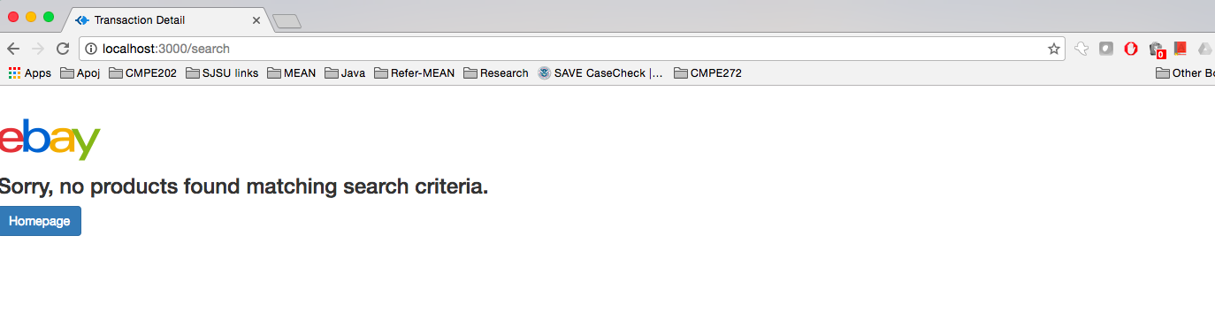

* **Product Info:**
  + The product information page shows the product name, price, seller details etc.
  + The user can directly add the product to his cart if it’s a direct sell, or if the product is in auction, he can place a bid. Bids take place over a period of 4 days.
  + User bid history is maintained in the bidding database.
  + If the product goes out of stock, the “buy” option is disabled.

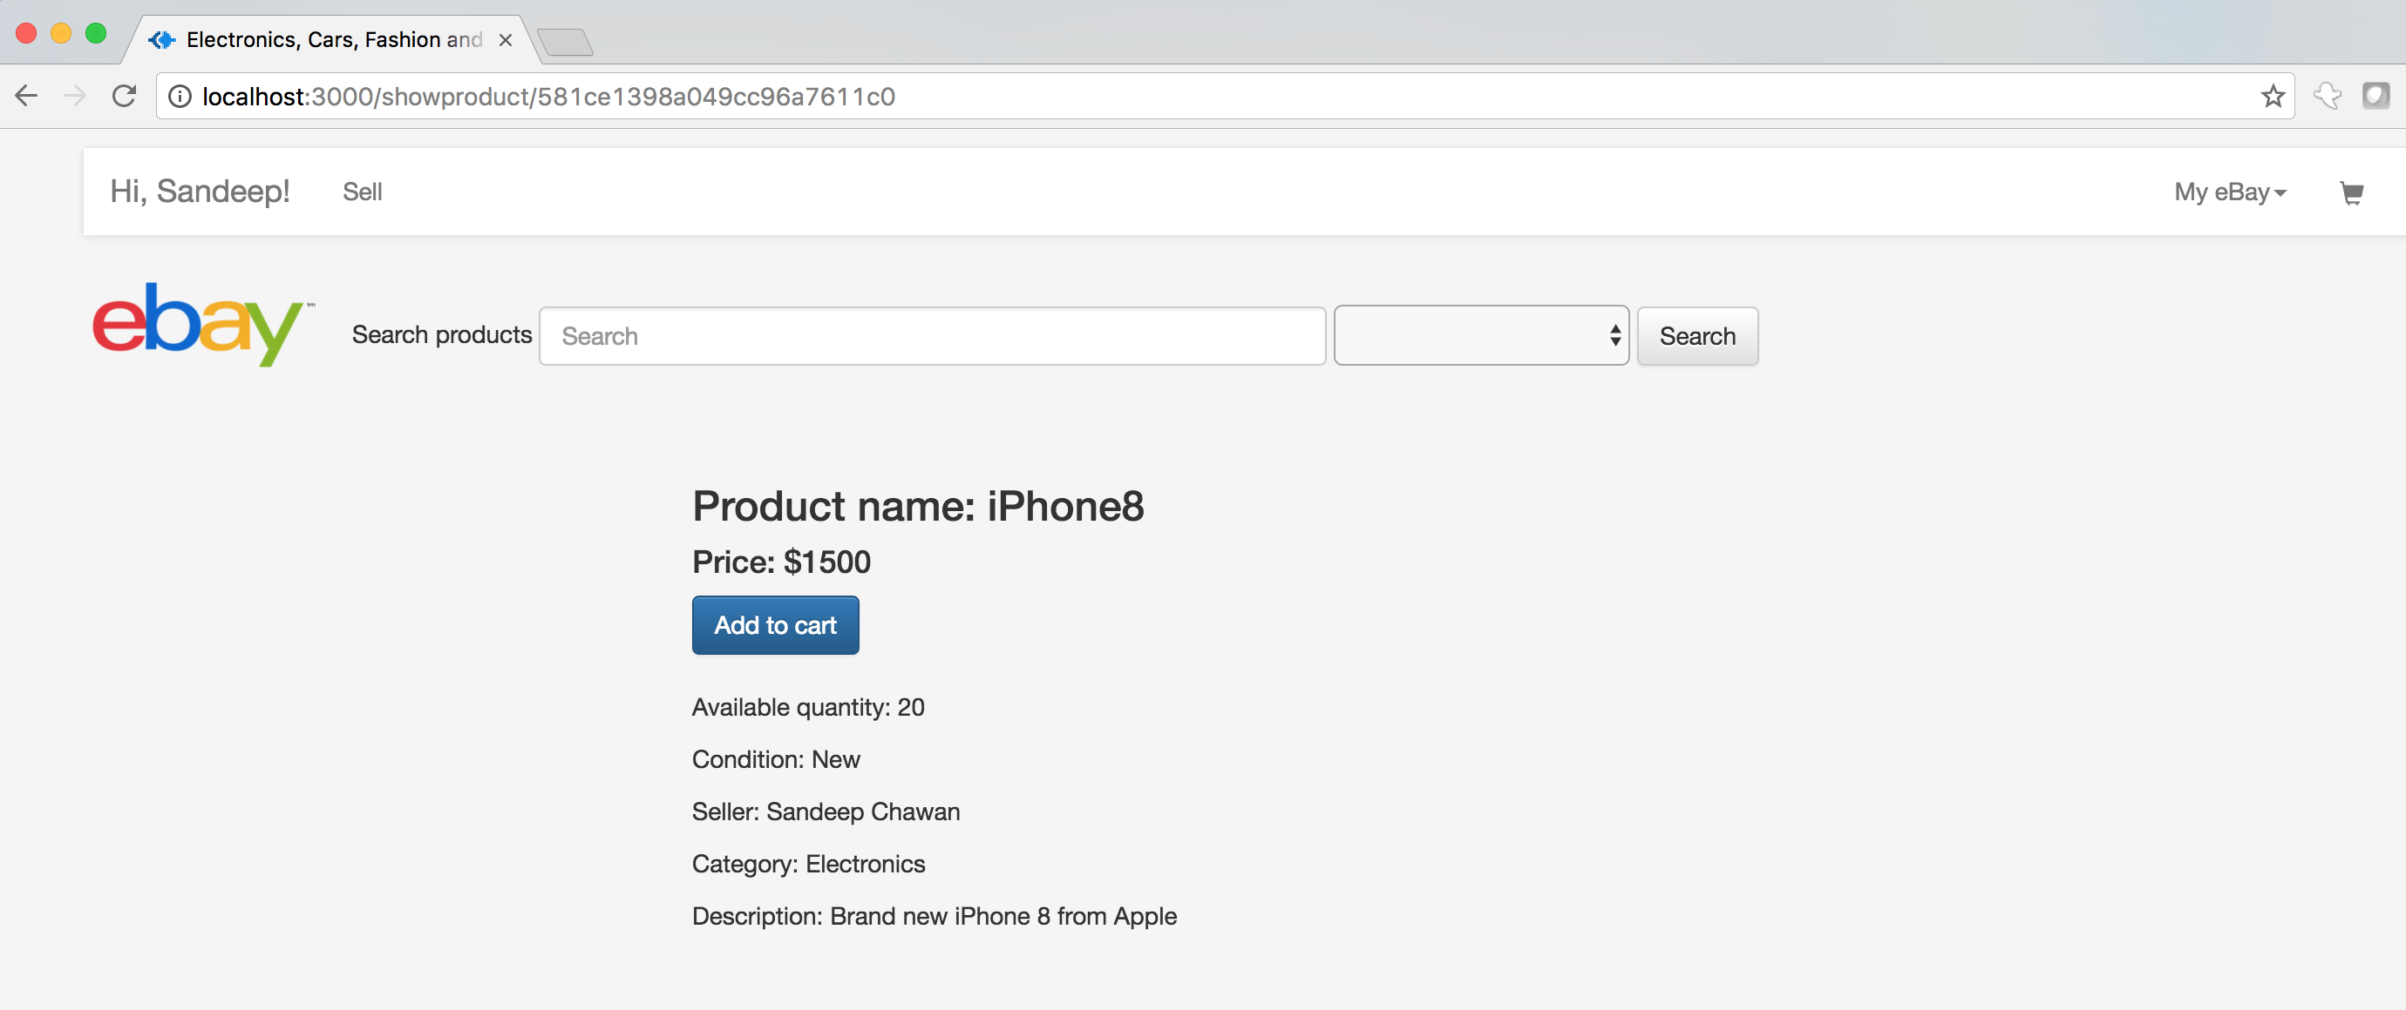

* **Sell Page:**
  + The user can either do a direct sell or an auction sell.
  + Here the details of product name, price, category etc. are captured and stored in the product collection of the mongoDB.

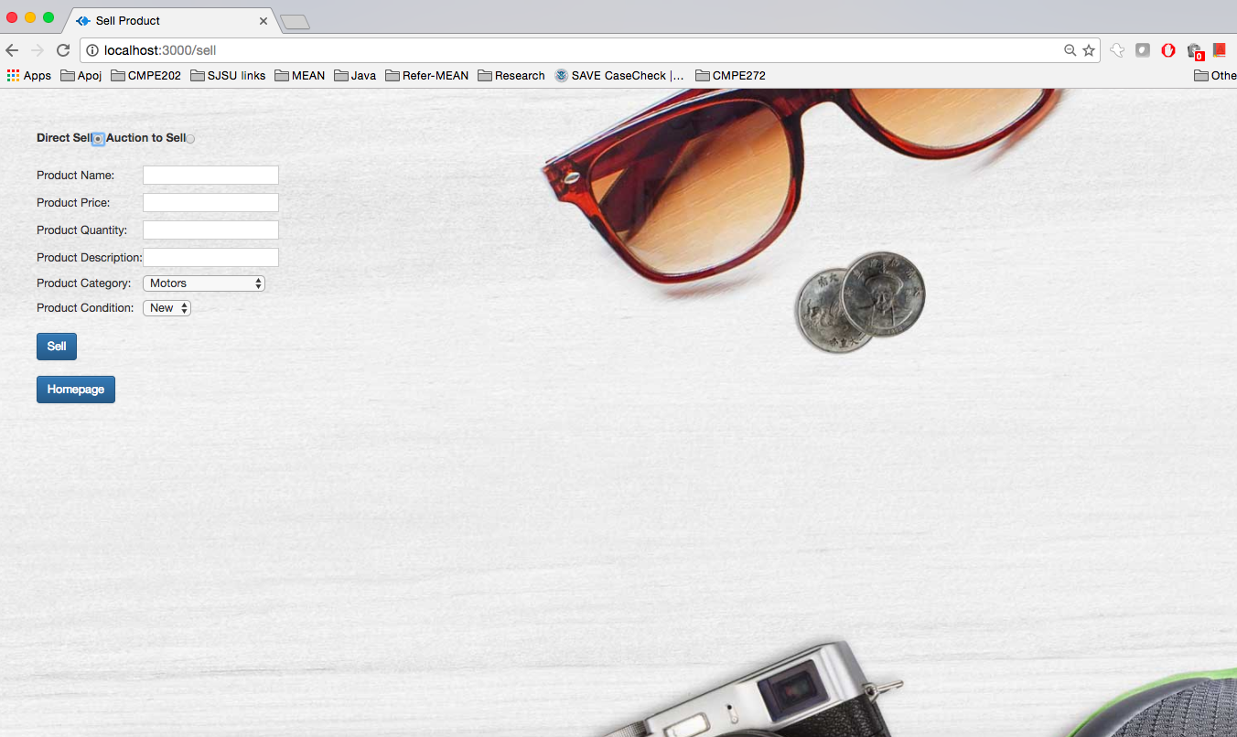

* **Bidding:**
  + User can place a bid over a product in auction. Bid takes place over 4 days. At the end of 4th day, item is added to cart of user with highest bid.
  + Bids are inserted into the bidding history.

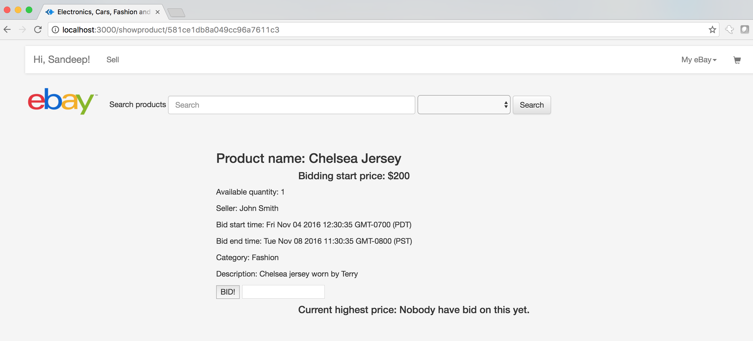

**After placing bid for 250$**

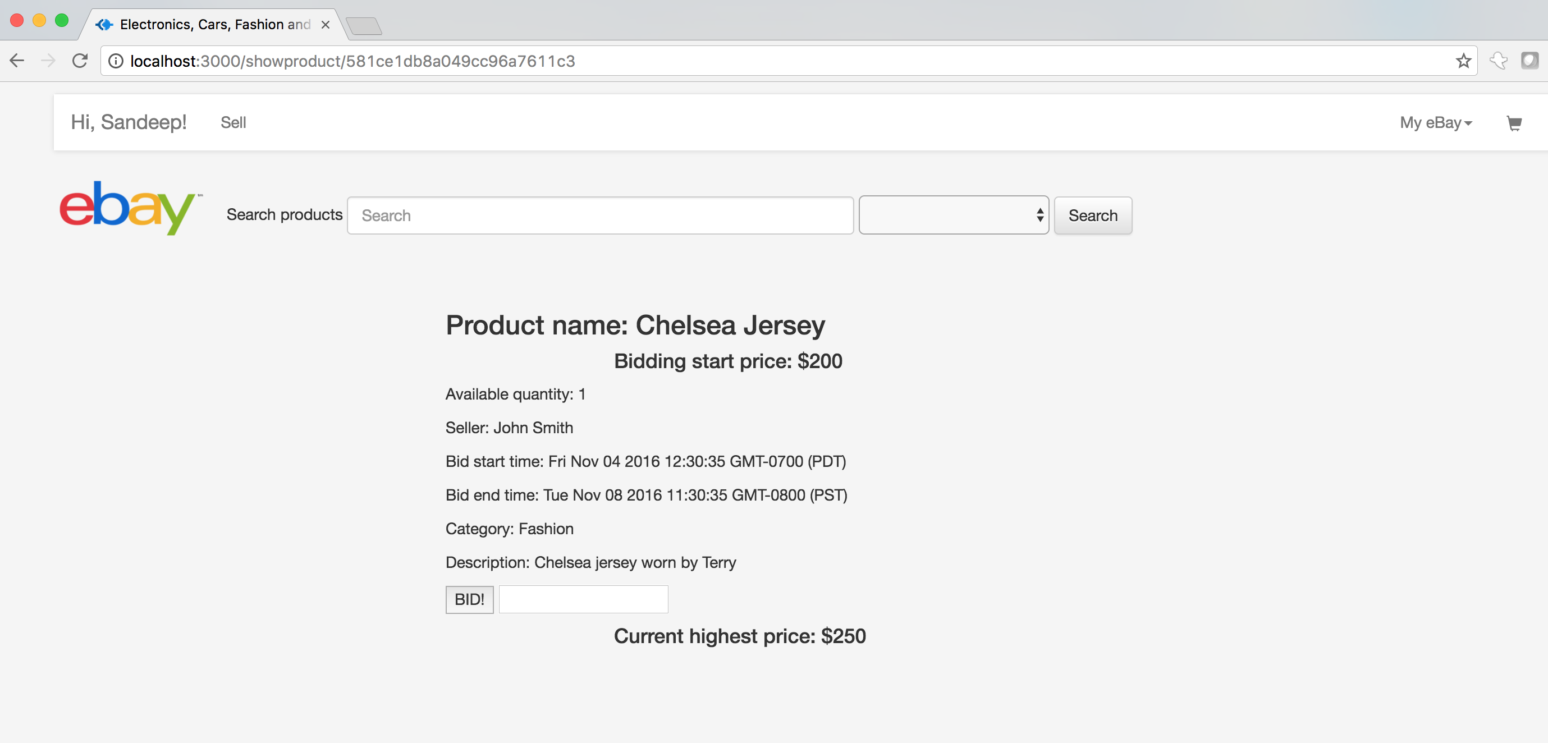

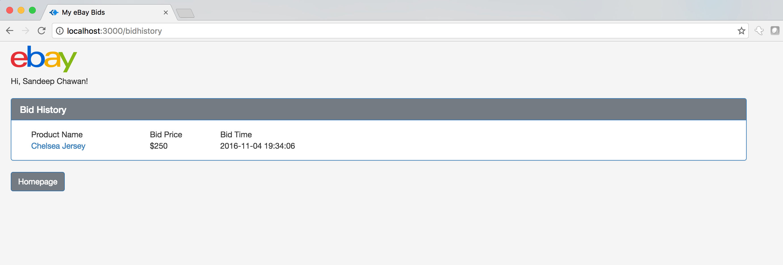

* **Cart:**
  + The cart shows the items currently added by the user.
  + The data is fetched from the “users” collection in the mongoDB.
  + Option is provided for user to remove items from the cart.
  + Once the user finalizes his cart items, he can checkout and make payment.
  + If the cart is empty, checkout is disabled.

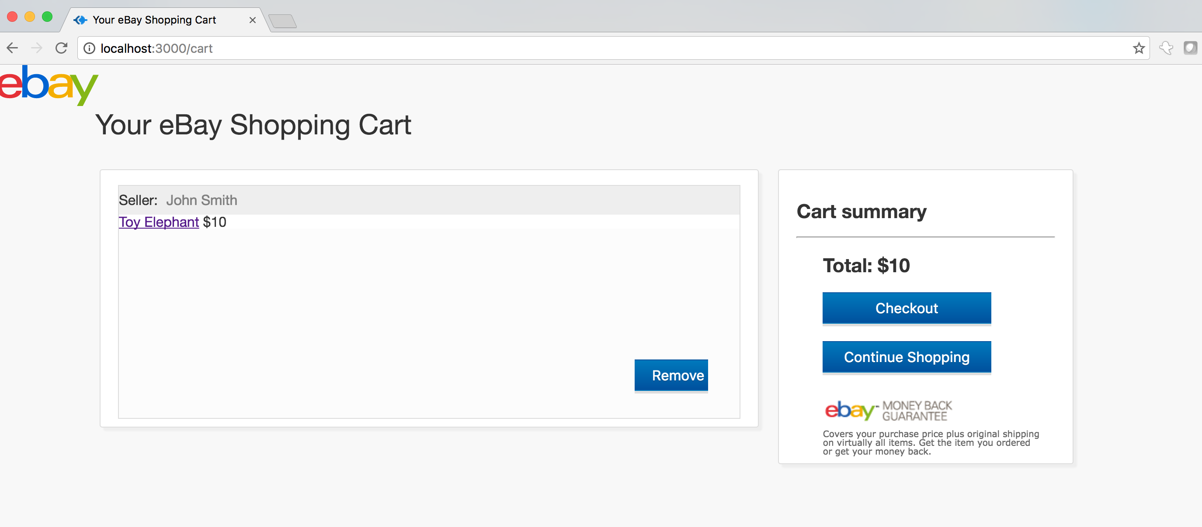

**After removing item from cart**

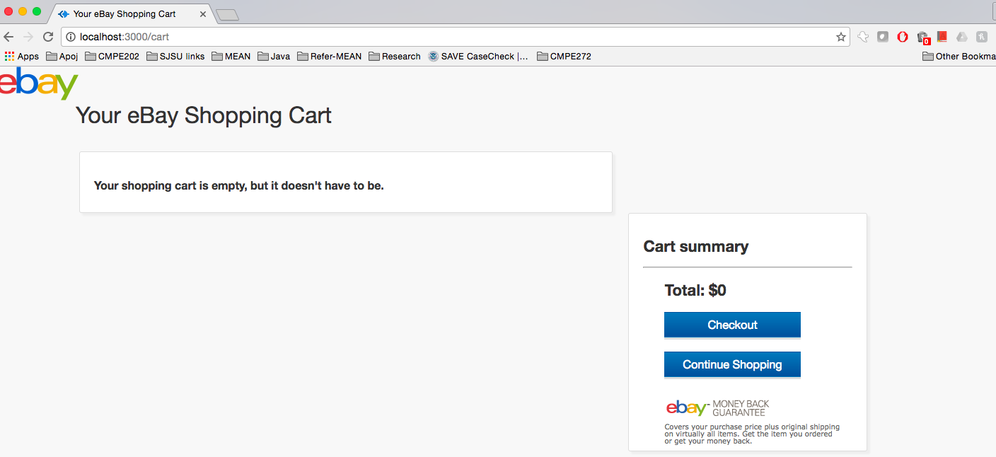

* **Payment:**
  + On the payment page, the user enters his credit card details- credit card number, expiry date, CVV.
  + Server side input validation is done to ensure the length of credit card number is 16 digits. Also expiry-date format must be valid and the CVV must be 3 digits.
  + After successful payment the cart is emptied and transaction is recorded in the transaction database.

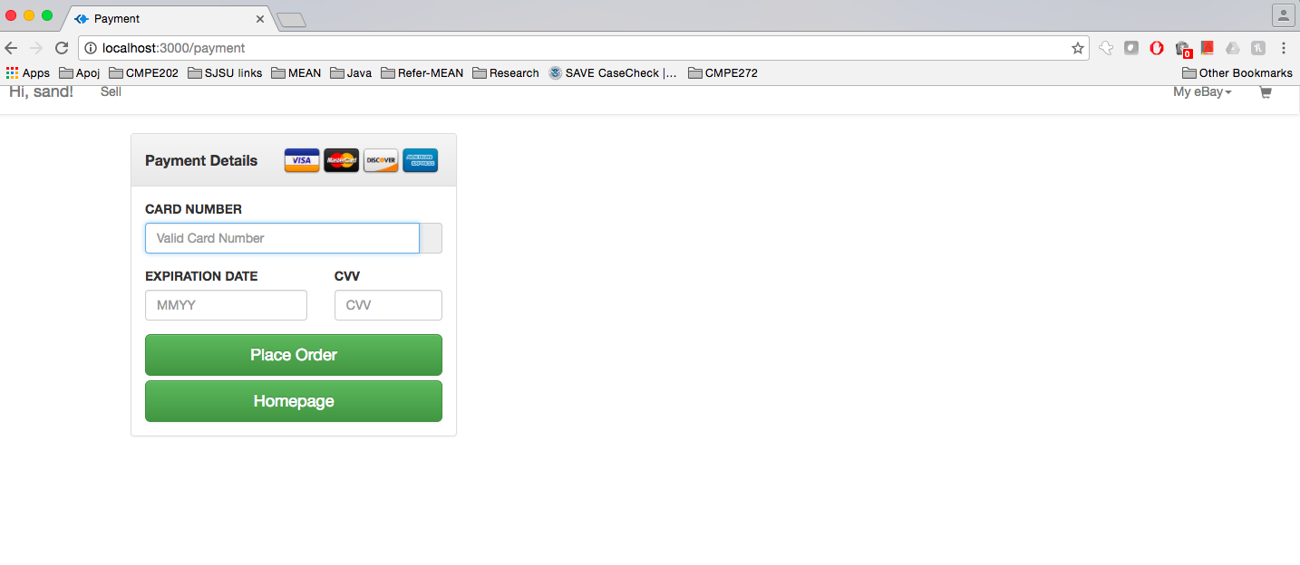

**After entering valid details**

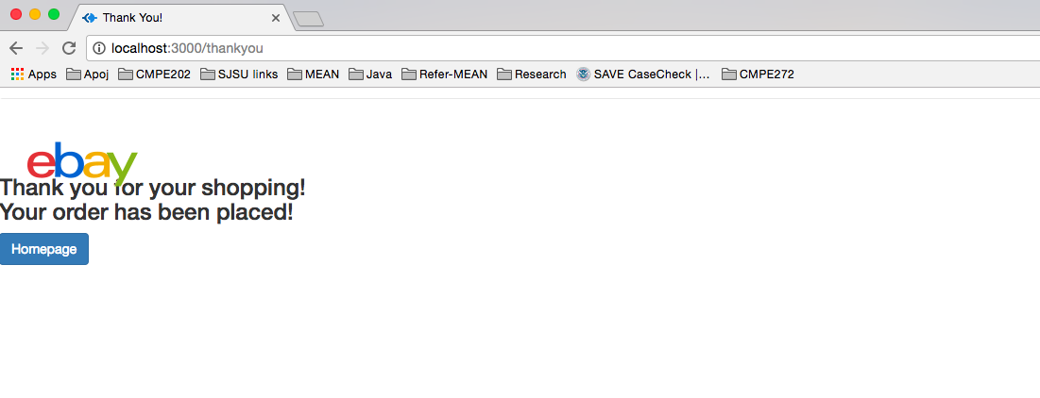

* **Transaction History:**
  + After successful payment the transaction is entered into the ‘users’ collection.
  + Money is deducted from the user and the users purchase history is updated.
  + Money is added to the seller account and the sellers selling history is updated.

**Purchase history**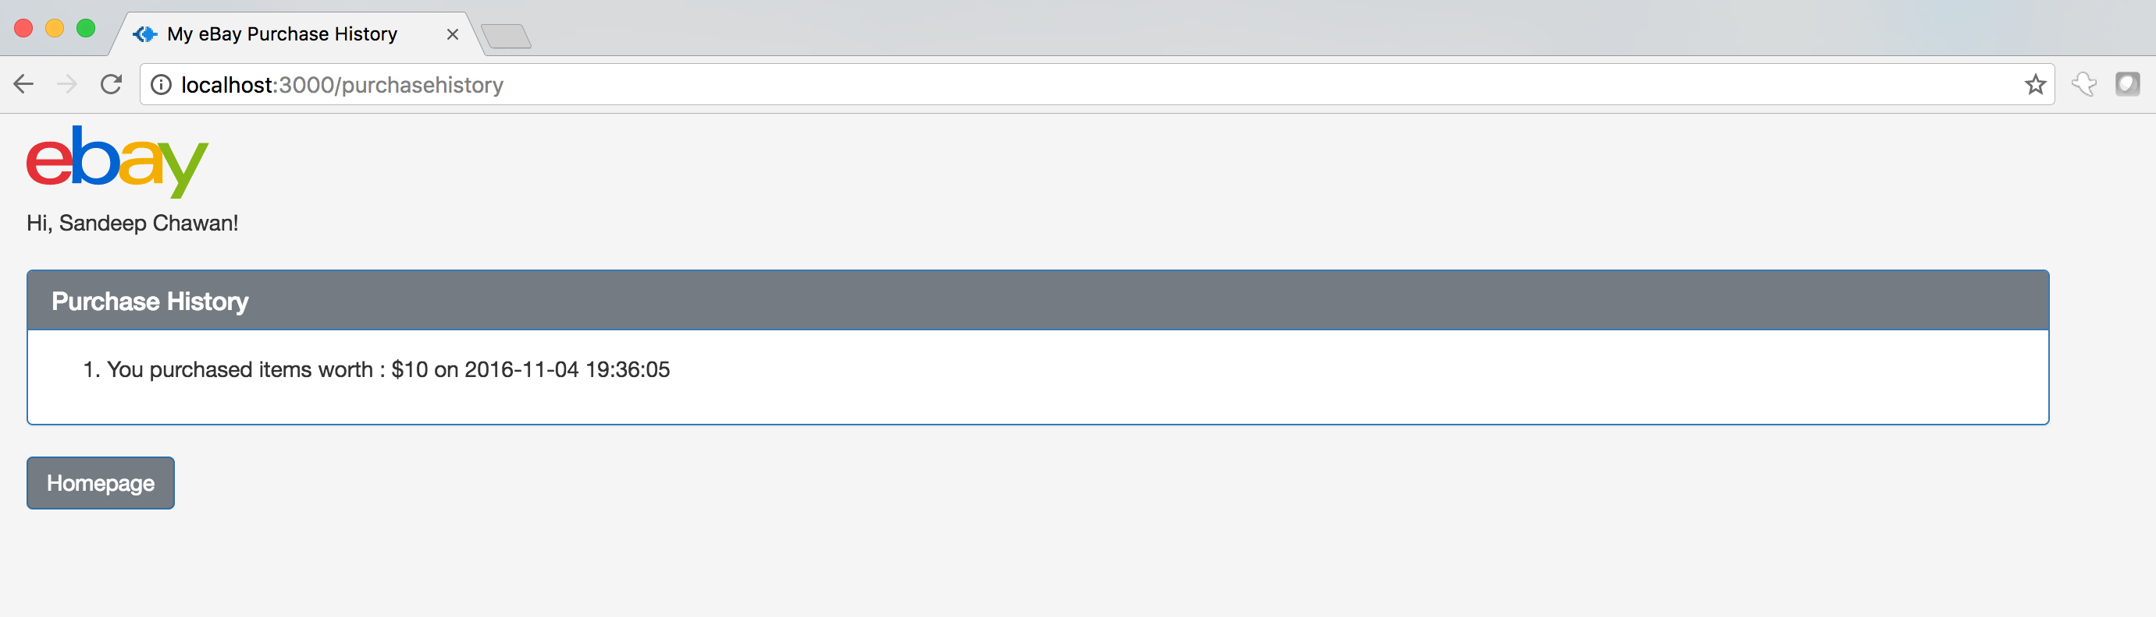

**Sell History**

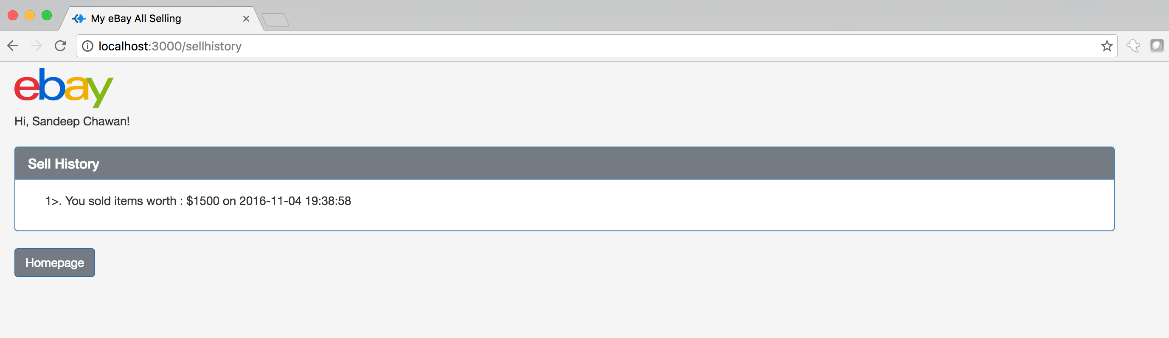

**Bid History**



* **User Account:**
  + The user account shows the complete user summary**.**
  + It shows user name, email, last login, purchase, selling, bidding history etc.
  + It also shows the amount of money user spent and the amount he earned from his sales.

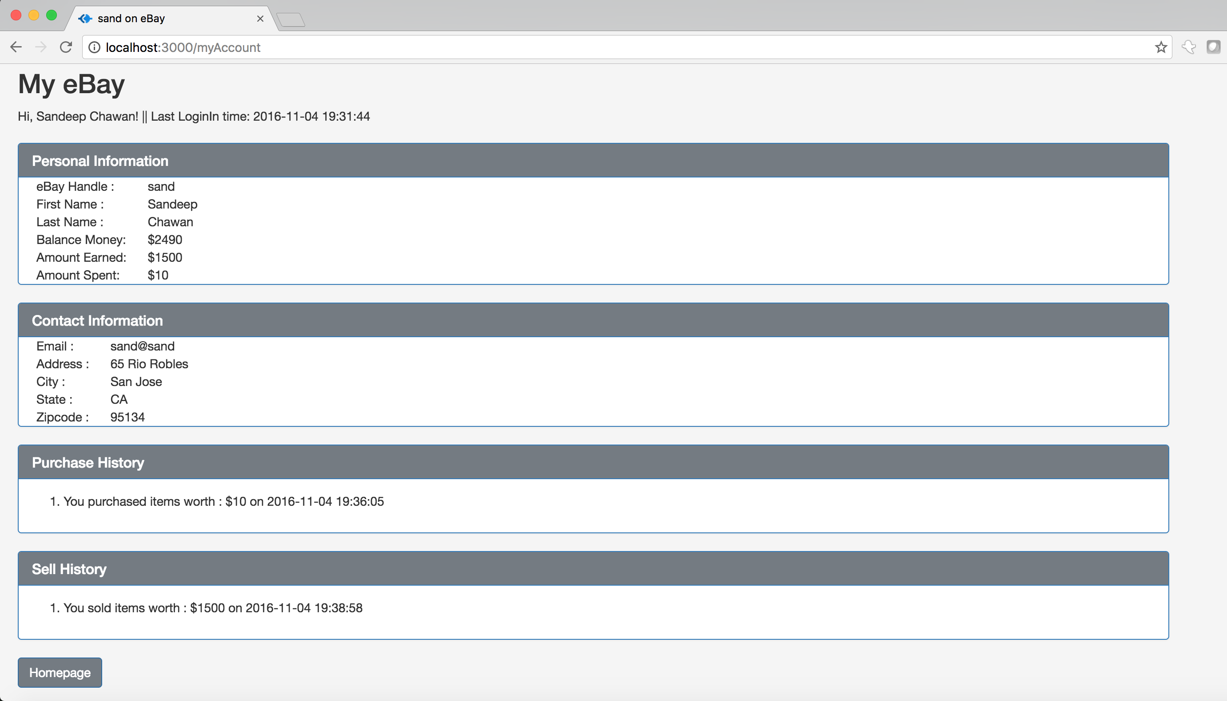

* **Logging:**
  + Click Logging:
    - User clicks are captured via Winston node module.
    - All the logs are captured in a file.
    - For every log, the user info, timestamp and the intention of the user is captured.

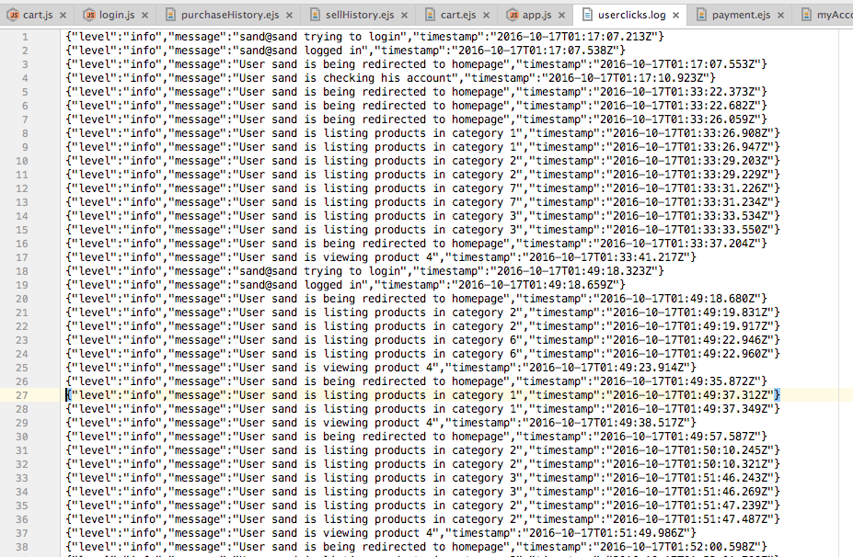

* Bid logging:
* User bids are also captured via Winston node module.
* All the logs are captured in a file.
* For every log, the user info, timestamp and the intention of the user info, product id, bid value, timestamp are captured.

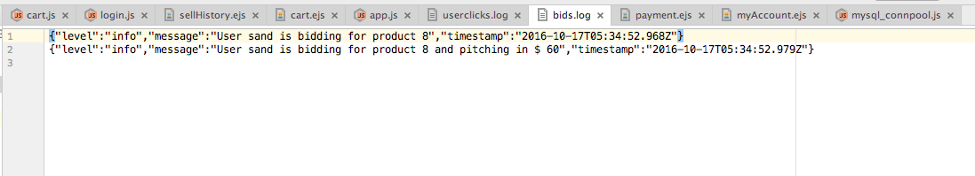

* **Connection Pooling:**
  + Connect using MongoClient connect only once.
  + Use the database returned by the connection and keep using it instead of new connect every time.
* **Database design:**
  + MongoDB is used to store all the information related to users, products, transactions etc.
  + Additionally, MongoDB is also used to store session.
  + The database used for storing sessions is the “sessionsebay” database.
  + The database used to store all other information is the “ebay” database.
  + The “ebay” database has 3 collections:
    - Users- to store all user related personal information, user cart, user history etc.
    - Product-to store all product related info such as product price, product name, bidding info related to product, product seller, buyer etc.
    - Category-to store all the different categories of products supported by the website.

**Jmeter results: After switching to MongoDB**

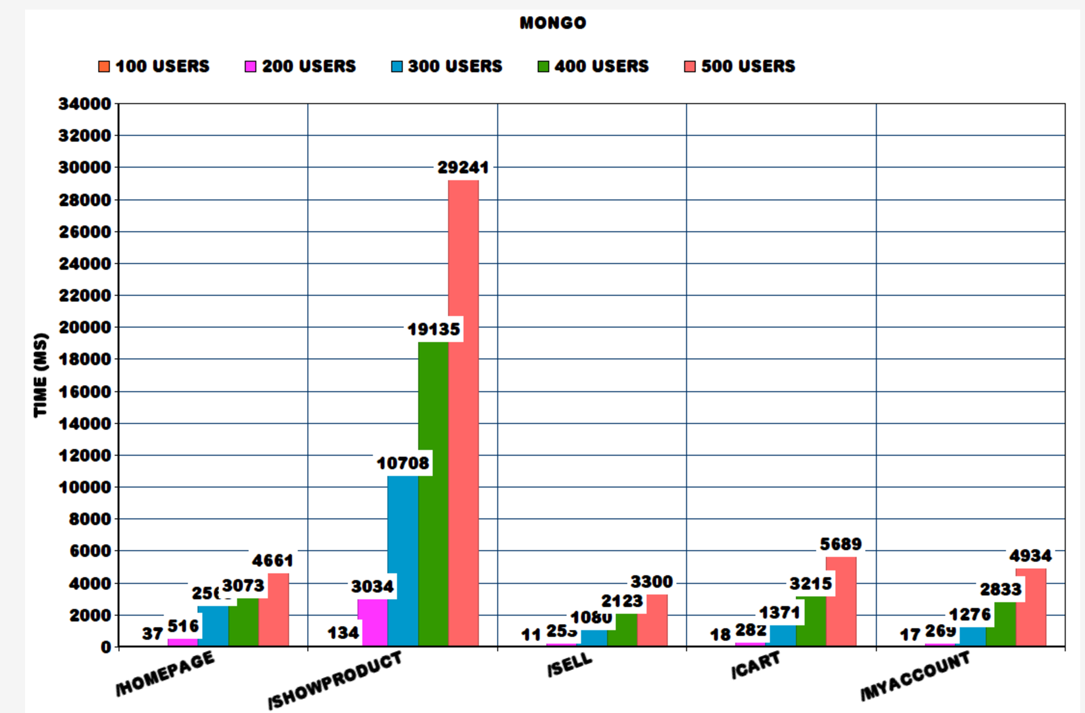

**Jmeter results: After switching to MongoDB with RabbitMQ**

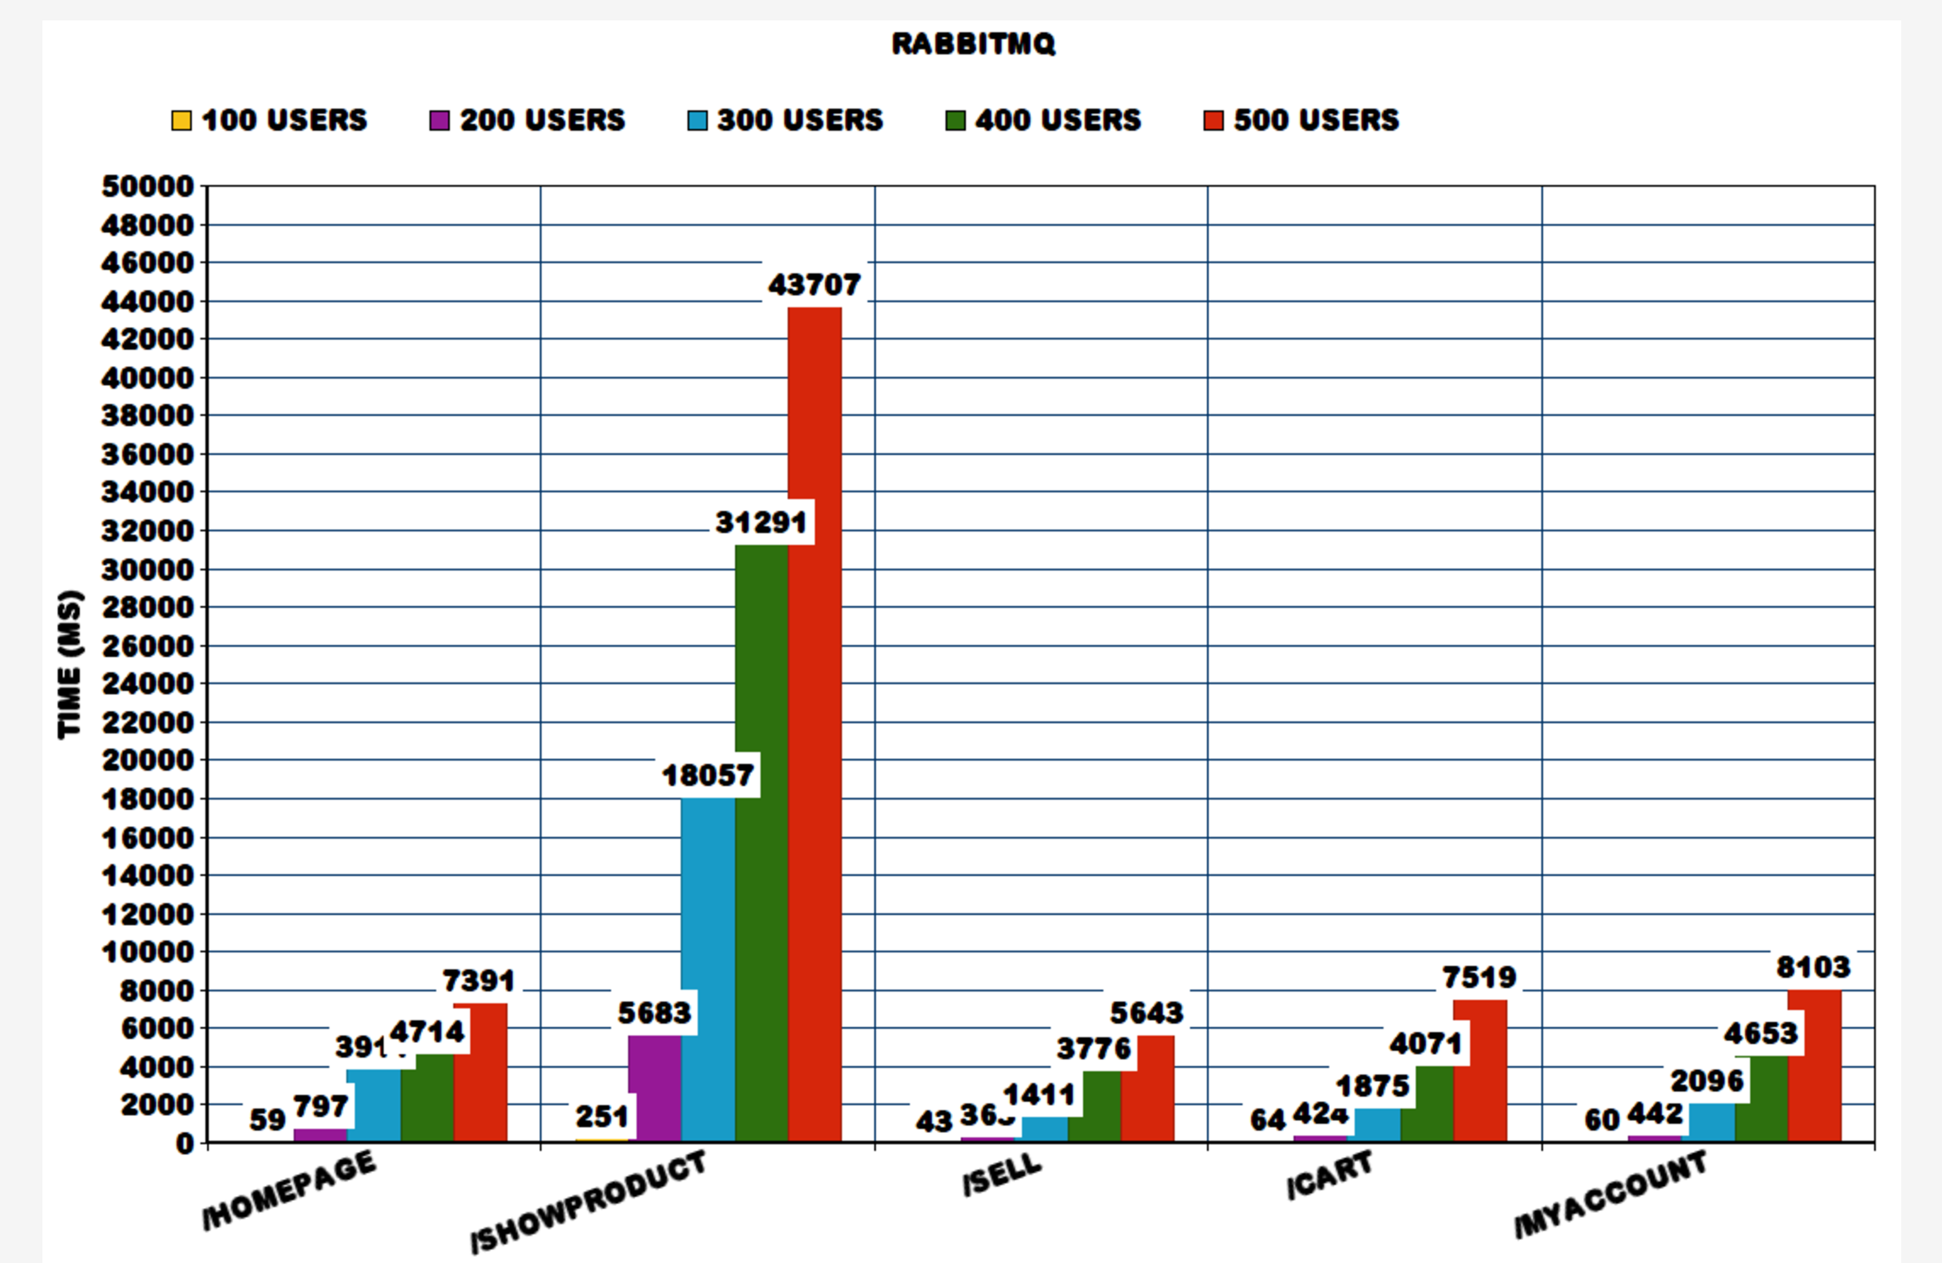

* As we can observe that the requests are taking more time for RabbitMQ as compared to the results without RabbitMQ.
  + This additional delay is due to the queue overhead of publishing and subscribing to the queue’s.
  + This mechanism would have produced good results if we would have had multiple servers handling the different web services.
  + Since we have only one server, it gets overloaded and takes more time to respond.
* We need to add more servers to scale.

**JMeter Results: MongoDB with Connection Pool with RabbitMQ**

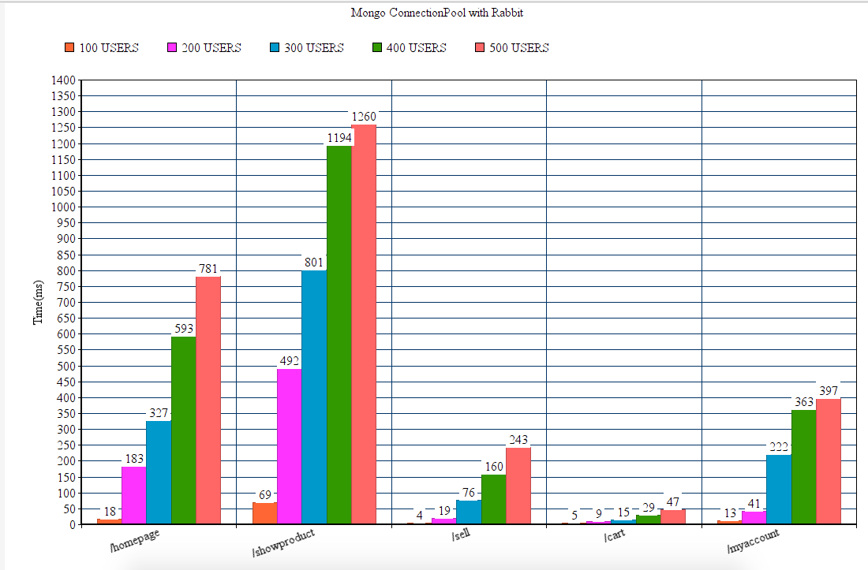

* After implementing connection pooling, the throughput has increased and the response times have come down.
* This is due to creating connections upfront, and re using the connections, instead of creating a new connection for every request.

**RabbitMQ handling incoming requests:**

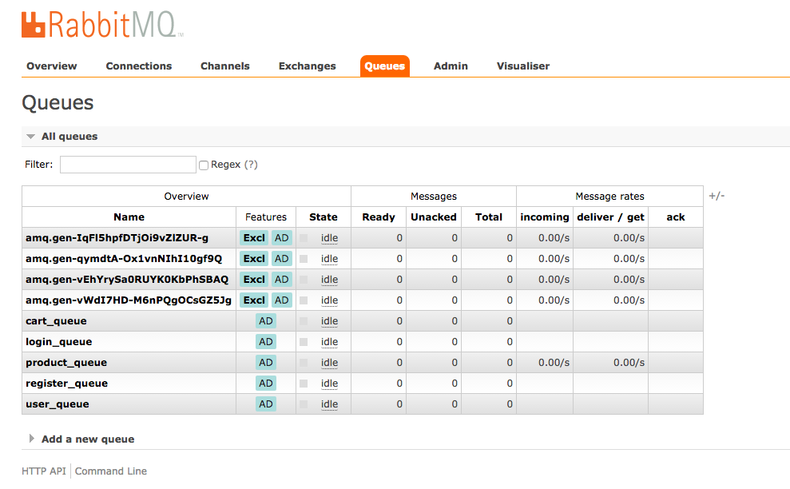

**RabbitMQ message publish rates:**

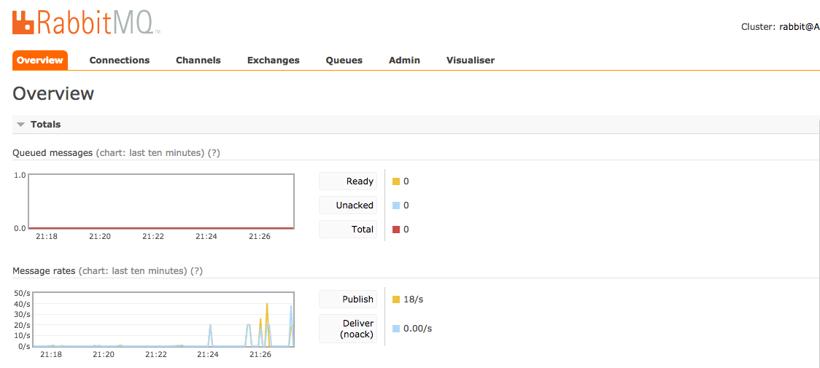

**Mocha Tests:**

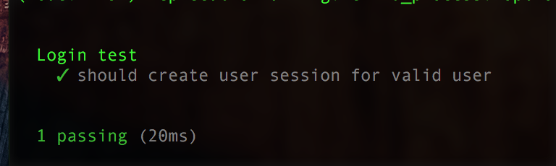

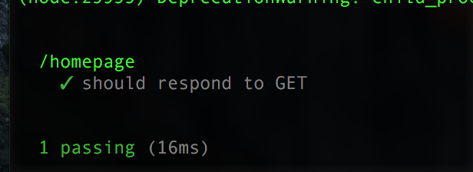

**When server is not running**

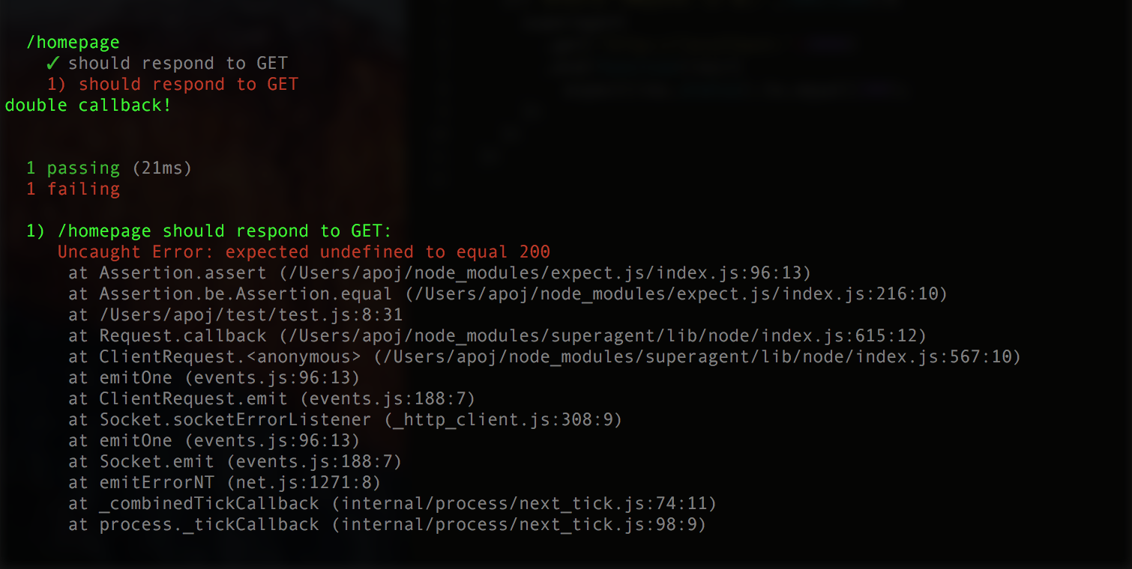

**Part 2: Questions**

1. **Explain what performance change RabbitMQ provides? Elaborate on the results of throughput with and without using RabbitMQ. If you find any increase/decrease in the throughput, explain the reason for the same.**

* As we can observe that the requests are taking more time for RabbitMQ as compared to the results without RabbitMQ.
  + 1. This additional delay is due to the queue overhead of publishing and subscribing to the queue’s.
    2. This mechanism would have produced good results if we would have had multiple servers handling the different web services.
* Since we have only one server, it gets overloaded and takes more time to respond.

1. **Compare passport authentication process with the authentication process used in Lab1.**

* The authentication process used in Lab1 was using client-sessions.
  + Client-sessions used to store the cookies in a file on the browser. The browser then sends that info back on every request, allowing our application to identify the user.
  + Client-sessions will encrypt and decrypt all the cookie values.
  + With a client-side scheme though, the session data is not on the server, so the server cannot be sure that it has been deleted on every client.
* Passport JS is capable of performing authentication and storing sessions.
  + It can store sessions on external stores such as MongoDB, MySQL etc.
  + Independent of which server receives the request, the server can pick up the session from database.
  + Passport JS also provides for authentication via most commonly used facebook/gmail/twitter etc. user-ID’s.

1. **If given a choice to implement both MySQL and MongoDB, specify which data of applications you will store in mongoDB and MySQL respectively.**

* If given a choice, I would store all the user related information (buyer, seller) in MySQL tables, as it’s easy to implement joins, instead of data redundancy.
* For the products which is a dynamic schema, it is appropriate to use a mongoDB as we never know upfront, what fields a product will contain. And with growing popularity of adding comments, reviews on products, we cannot predict what may come up in the future. And given the high incoming rate of new products being added to the website, mongoDB is a good choice.
* MongoDB is also suitable for storing pictures, reviews(whose length we don’t know upfront)
* For performing complex tasks like checkout system, adding transactions to user’s history based on information of buyer, seller, product etc., MySQL might be a better choice.
* For storing bidding information, mongoDb might be preferable as there is a high incoming rate for bids placed across products.
* A user cart can also be maintained in mongoDB, allowing easy addition/removal of products to the cart.
* For storing sessions, mongoDB is preferable.
* The ideal way would be a hybrid deployment of MongoDB and MySQL. It’s a matter of using the right tool for the job.

**CLIENT-SERVER Screenshots**

**LOGIN:**

*Server*

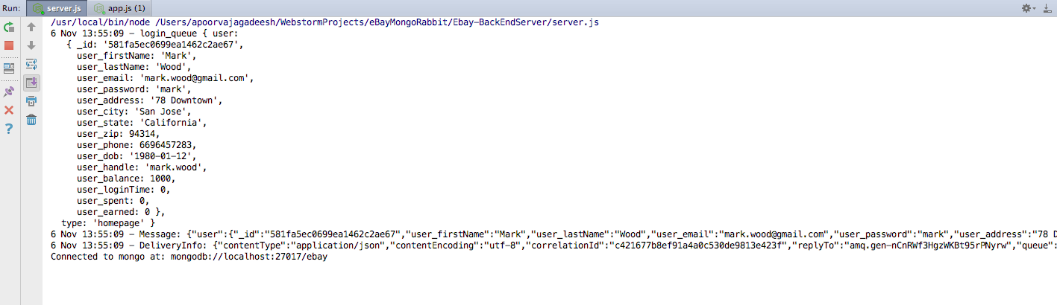

*Client*

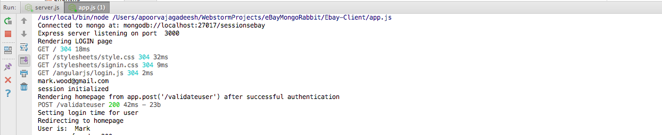

**REGISTER NEW USER**

Server

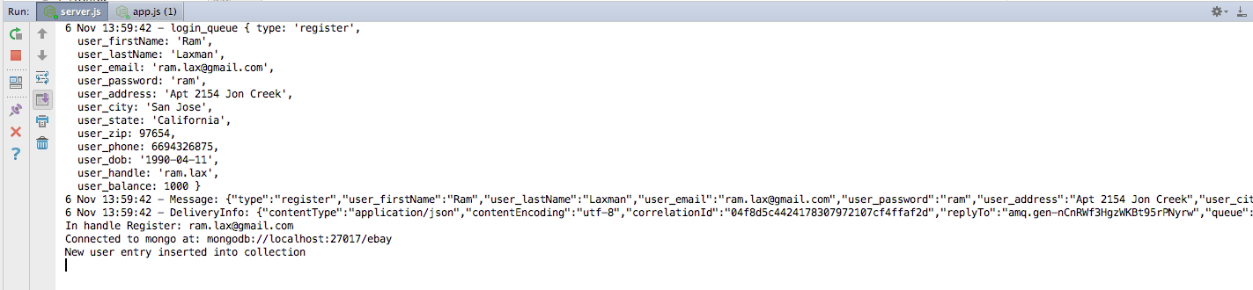

Client

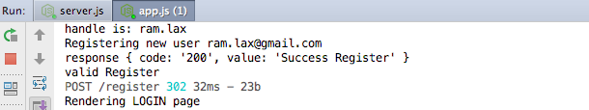

**RENDER PRODUCT INFORMATION**

Server

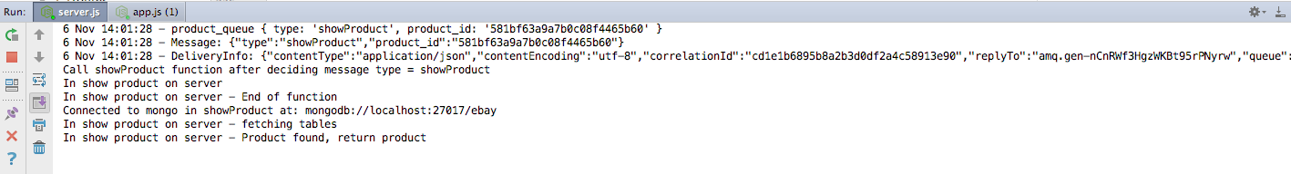

Client

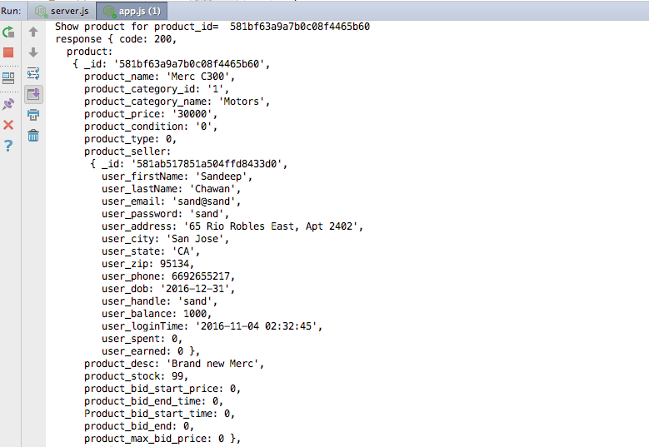

**Add Product to Cart**

Server

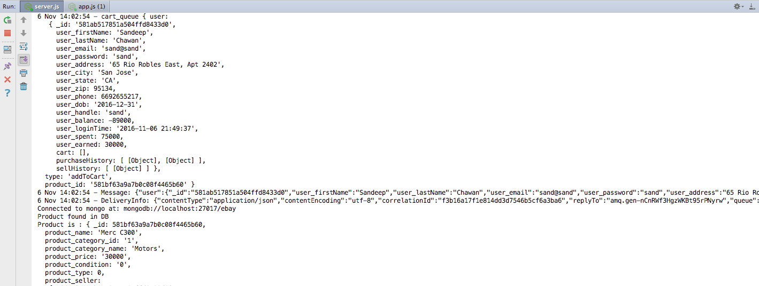

Client

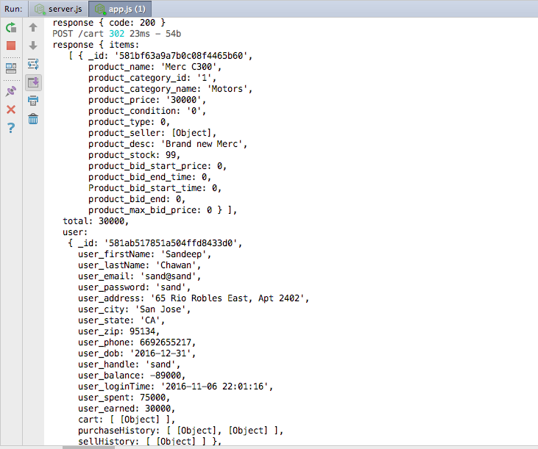

**Remove item from Cart**

Server

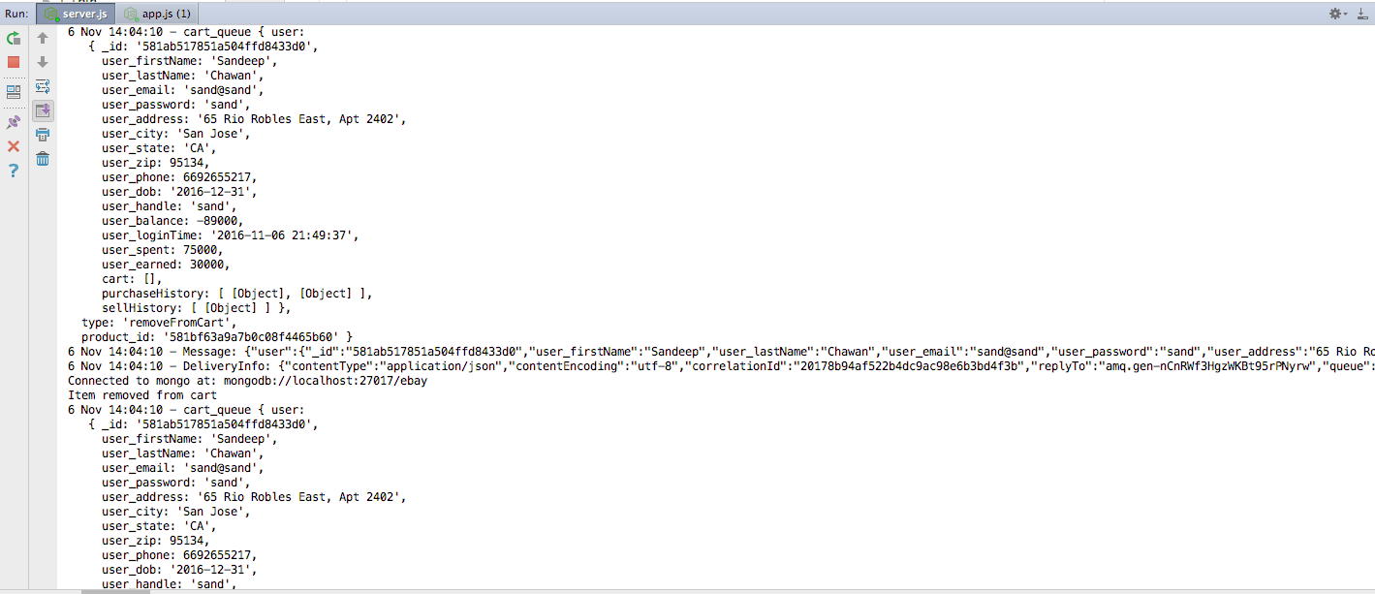

Client

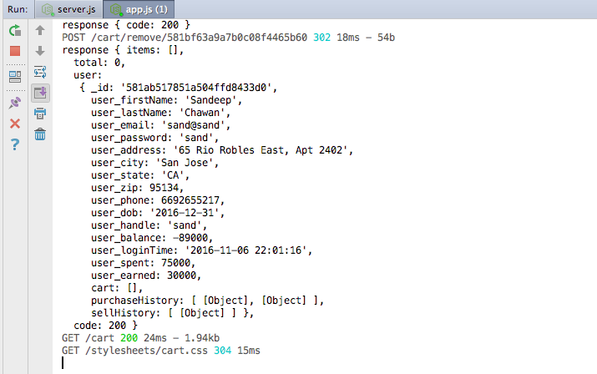

**Cart Checkout**

Server

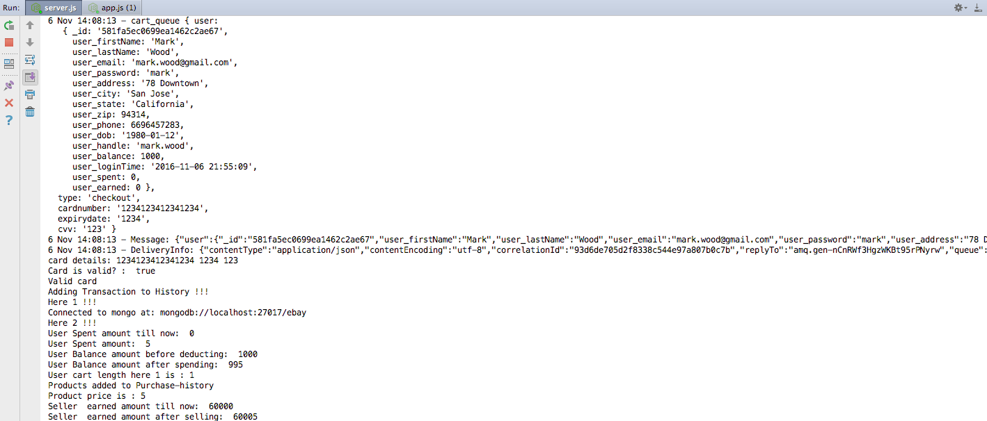

Client

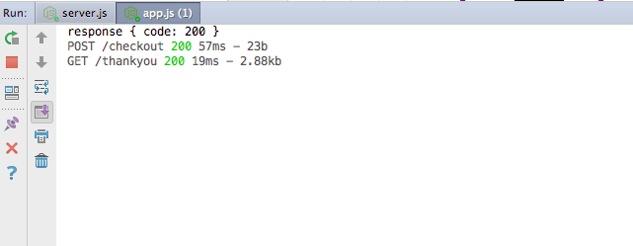

**Sell Product**

Server

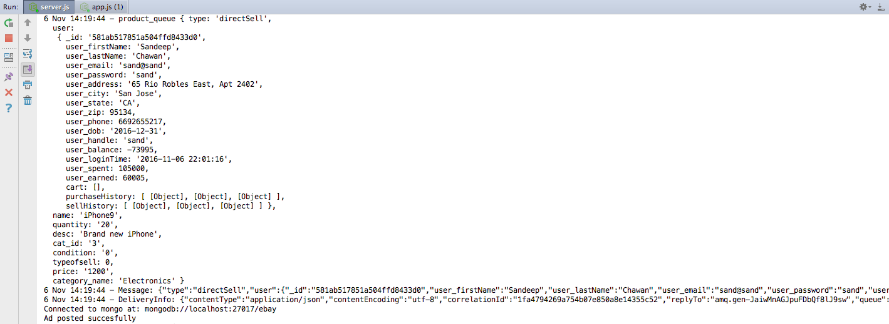

Client

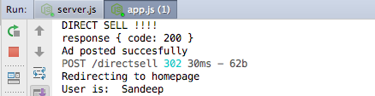

**Search Product**

Server

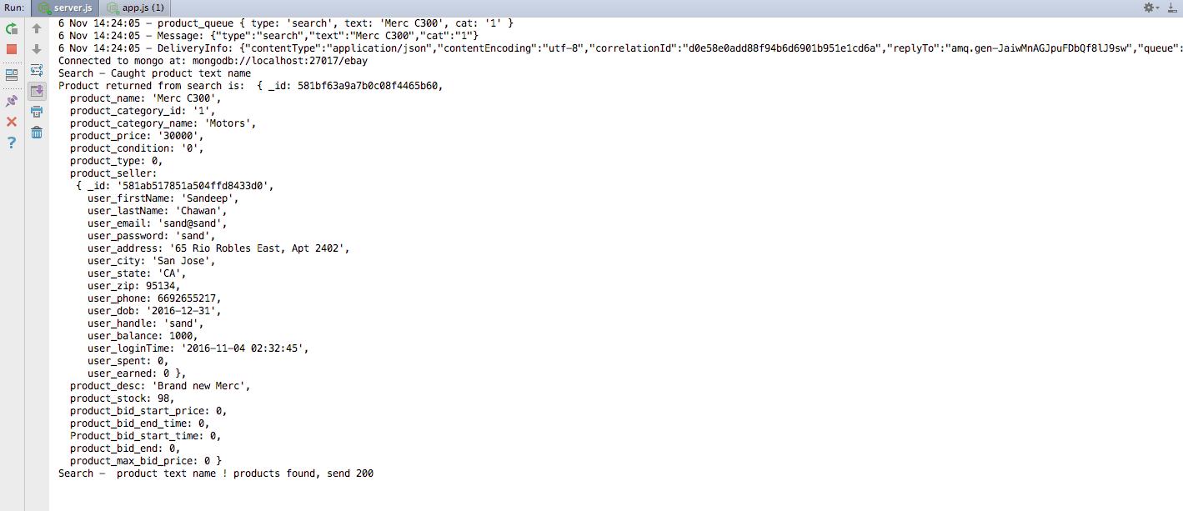

Client

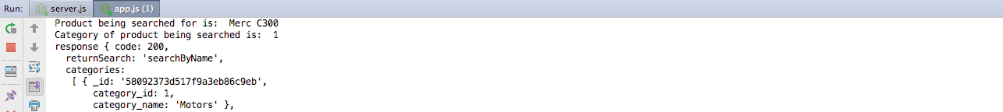

**Render Account Details**

Server

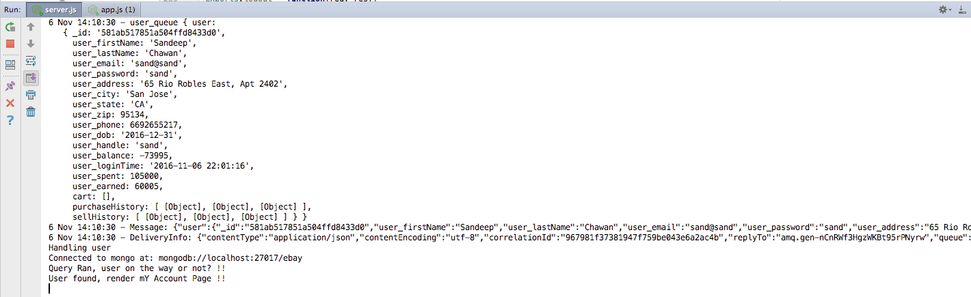

Client

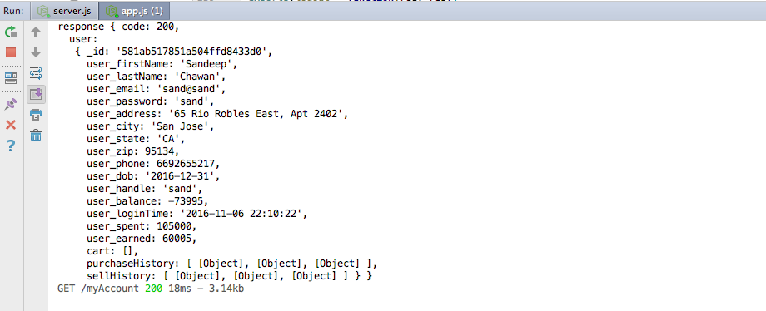

**GitHub Link:** [**https://github.com/sandeepchawan/CMPE-273-Lab2-EbayMongoRabbit**](https://github.com/sandeepchawan/CMPE-273-Lab2-EbayMongoRabbit)

Access given to Ankil0007